Resource Catalogue
Tags: the plant fairy, plants, plant puzzle, tree investigation, tree album, evaluation, project idea, EVS
Lesson: The Plant Fairy Theme: Plants Grade: Three
- Activity idea to engage learners
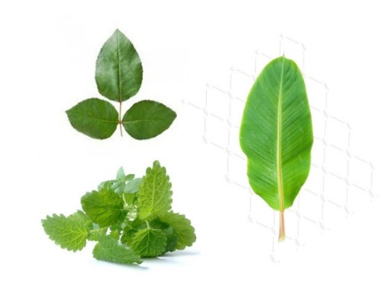
- Find the leaf
Leaf picture cards
Show students some leaves or pictures of leaves and ask them to identify the names of the plants to which they belong. A discussion on how leaves vary in size, shape, texture etc. can be carried out.
Resources: Pack of Leaf Picture Cards
- Exploration activities
- Plant puzzle-
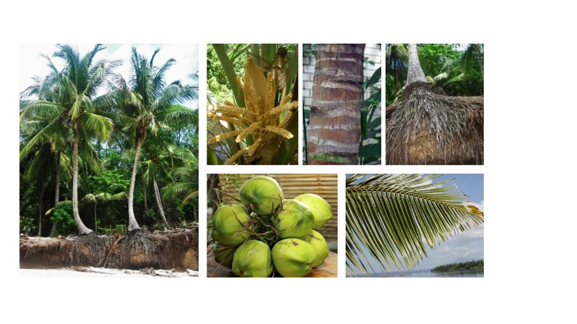
Give students pictures of different parts of different plants and ask them to group them plant-wise.
Discuss with children what they already know about the plants that they have identified: the name, uses, colour of the flower, shape of the leaf, etc.
Students can compare each part of different plants in terms of shape, colour etc.
There can be a discussion on the surprising aspects of plants- e.g. Banana tree produces fruits only once in its lifetime.
Resources: picture cards of plant parts, readings on surprising aspects of plants.
- Tree investigation-
Students can investigate a nearby tree. The objective is to build curiosity and documentation skills of the students. Observations on:
- leaf shape, colour, margin;
- tree bark colour, texture;
- stem- long, short, fat, thin;
- animals- living in the tree, visiting the tree;
- flowers- colour, presence of smell, size;
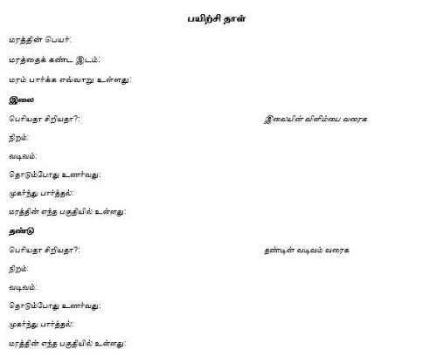
- fruits- colour, size​ etc.
These observations can be made in groups and documented individually. In third grade, writing need to be made compulsory.
Resource: Tree investigation protocol and data collection sheet
- Make a tree album-
Create an album of a tree nearby by collecting leaves, flowers, fruits, samples of the bark, etc., to create an album on plants. Children can write its name and uses and also attach the tree investigation sheet to it
Resource: Sample format of a tree album
Extension for grade 4- The observation for tree investigation can be continued for six months to understand the seasonal variation. Questions such as when do the trees flower, when do the fruits appear, do the trees shed leaves, etc. can be observed and noted.
- Discussions on exploration
Using the tree investigation sheet or the tree album, students can share what they have explored. Discuss other parts of the plant such as height, size,function of leaves, stem, roots, flowers, fruits etc.
Resources: Reading references for teachers
- Story time in classroom:
யாருடைய தோட்டம்:
தினமும் தண்ணீர் ஊற்றிச்செடிகளை வளர்க்கும் இரு குழந்தைகள் “இத்தோட்டம் எங்களுடையது” என்று பேசிக்கொள்கின்றனர். அப்பொழுது தண்ணீர் சொல்கிறது. இல்லை இல்லை தோட்டம் என்னுடையது. நான் இல்லாவிட்டால் செடி வளர முடியுமா? என்று நுழைகிறது. அதைக்கேட்ட சூரியன். “என் ஒளியில்லா விட்டால் செடி வளருவது சாத்தியமே இல்லை” இப்படியாக நகருகிறது கதை. ஒவ்வொருவரும் தோட்டத்திற்கு செடி/கொடி/ மரம் வளர எவ்வளவு முக்கியம் என்பதை தானாகவே உணரும்படி கதை அமைக்கப்பட்டுள்ளது.

விதை
இது ஒரு படக்கதை. விதை விதைப்பது. முளைப்பது. தண்ணீர் ஊற்றுவது. வளர்வது… என நாம் செய்ய வேண்டியதையும் மரம் வளர்ந்து வருவதையும் இணைத்து காட்சிபடுத்தியுள்ளது. மரம் செடி வளர்த்தல், போன்ற அறிதல் செயல்பாட்டுக்கு உதவியாக உள்ளது. முதல்நிலை வாசகர்களுக்கான நூல்.

Resources: Stories and discussion guide
- Evaluation of learning: Please refer to the evaluation rubric attached as a resource.​

